**Personal Task Log/Journal:**

* Fully modelled textured rigged and animated the first enemy unit; the fungus friend
* Fully modelled and textured a hallucinogenic mushroom asset
* Fully modelled and textured a convoy vehicle (We have decided against adding this to the game due to a conflict of visions and expectations of the games art style)
* Modelled rigged and fully animated all the turrets and interactive towers present in the game with the exception of the core defense objective.
* Fully modelled textured rigged and animated the “Wongle Worker”, a friendly creature that fulfils many tasks around the players base.
* Developed a hat for the Wongle Worker with texture variations for visual flavor and for role indication *(Wongle Workers are a species, they are intended to spawn with diverse visual traits and professions. Hats are an element of that. The system will most likely spawn Wongles with a percentage chance for different textures and hat elements so that all new Wongles look different.)*
* Developed (Fully modelled, textured and weighted) a series of tools for the Wongle Worker to use for it’s various functions including:

-Trumpet (animated)

-Wooden Sword

-Suitcase

-Bucket

* Developed vision document with team consultation
* Set up the bulk of the information present on the Trello (<https://trello.com/b/PUA8zh12/legal-substances-farming-tower-defense-empire>) to help with task assignment, structuring, and required output

**Challenges during development:**

* Perhaps due to a lack of communication, the art style has experienced disparities between each person making assets for the game. That’s not to say that there has been no communication, but that rather more communication was needed, especially in regards to the theme, poly count, and color scheme of the game.
* Despite attempts to emphasize the importance of getting out assets before Thursday (to prevent a panic and hasty implementations) there have still been problems amongst the group with getting out art assets in a timely manner.

**Artwork Developmental Showcase:**

**Enemy Unit (Fungus Friend)**

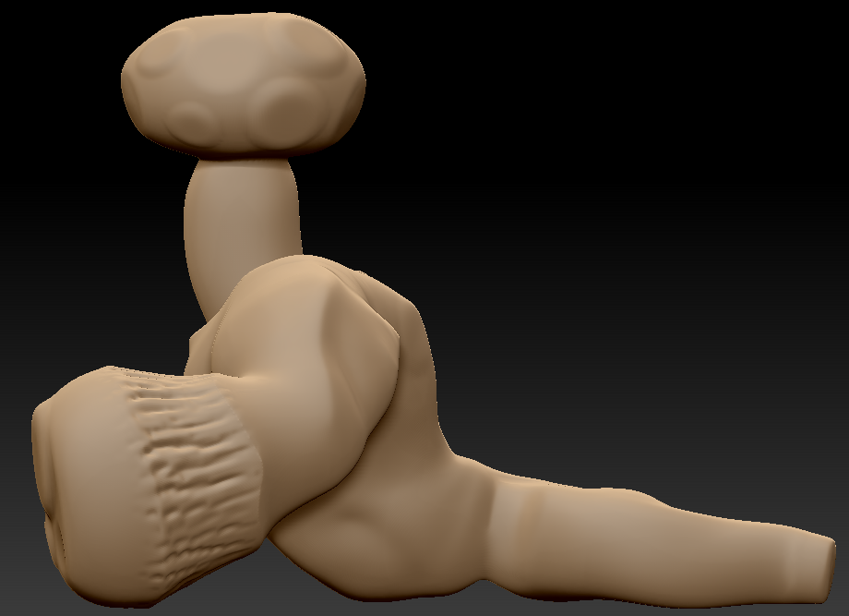

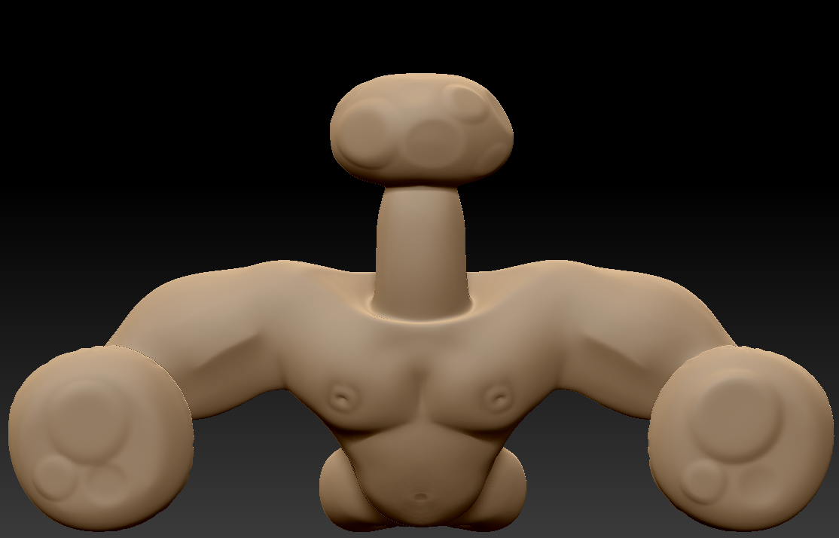

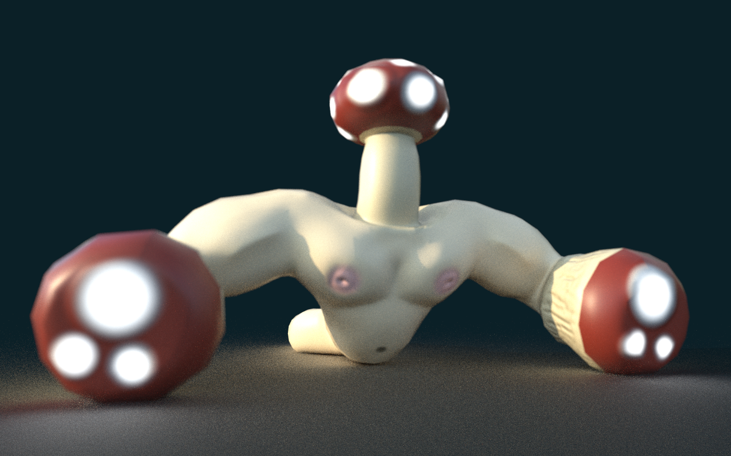

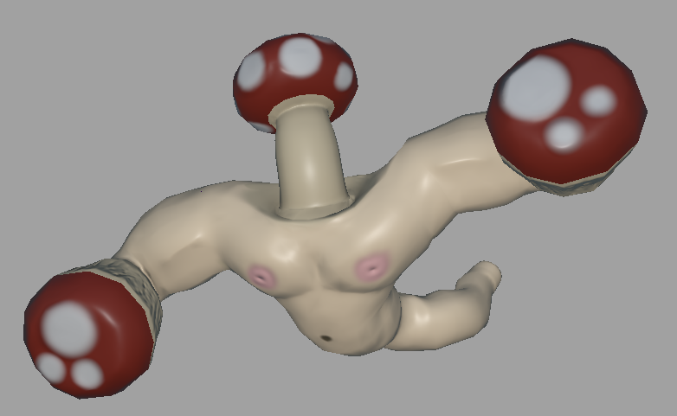

**Wongle Worker + Tools/Cosmetics**

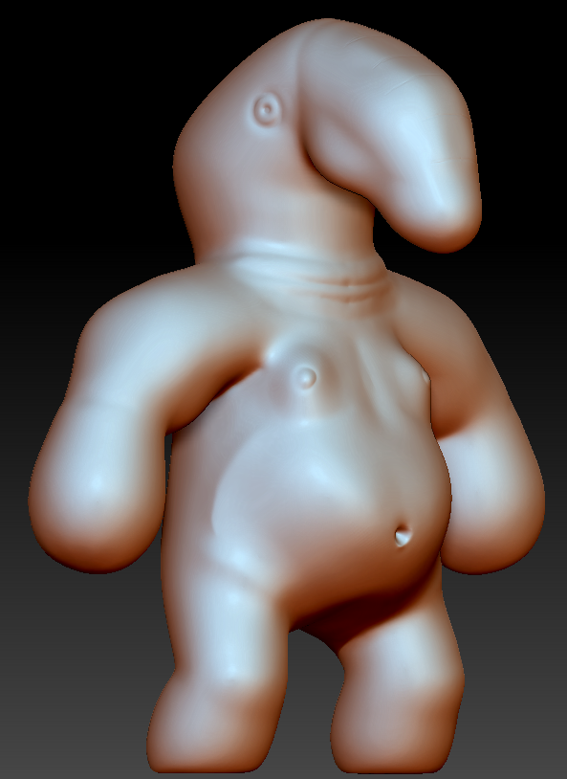

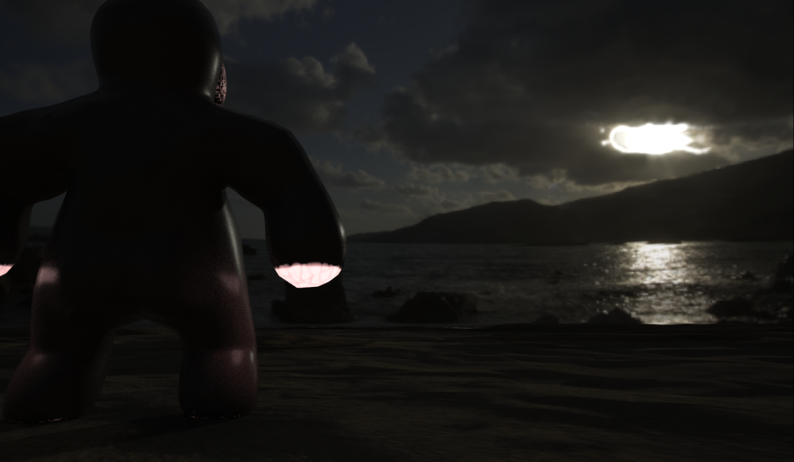

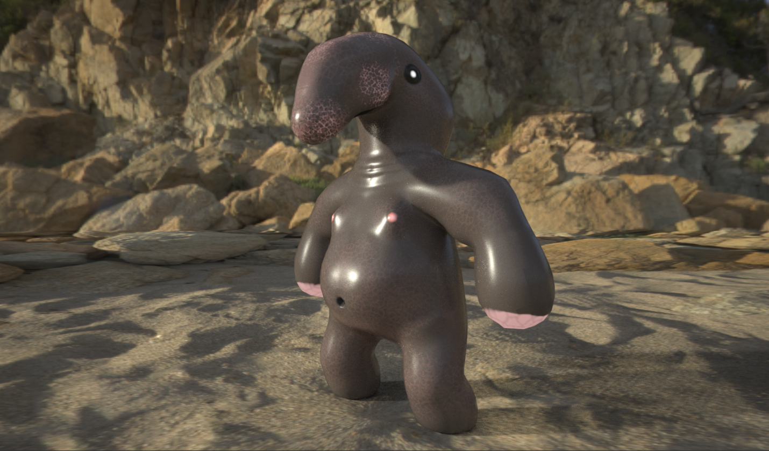

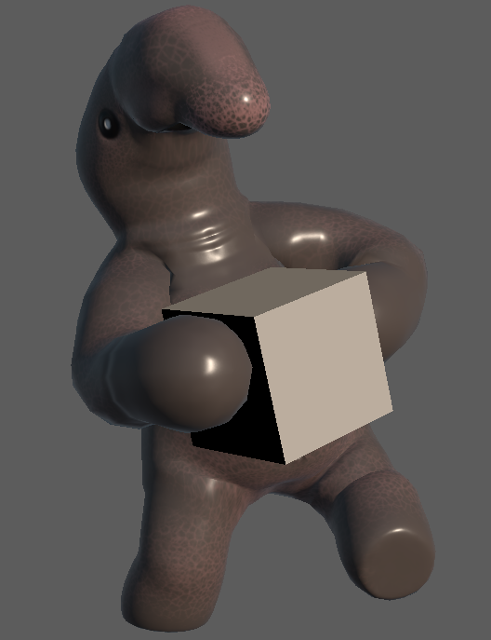

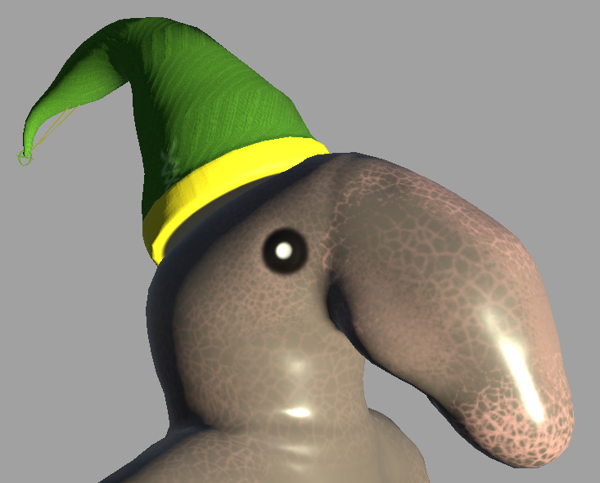

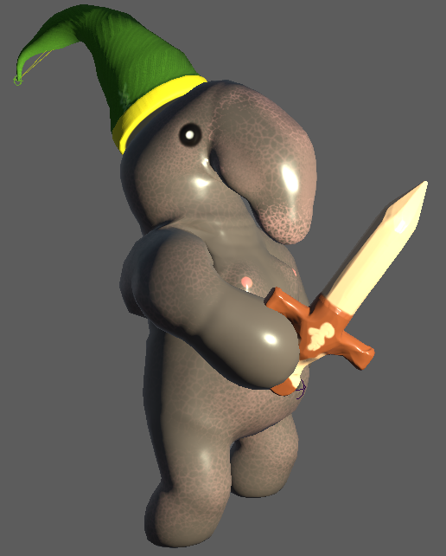

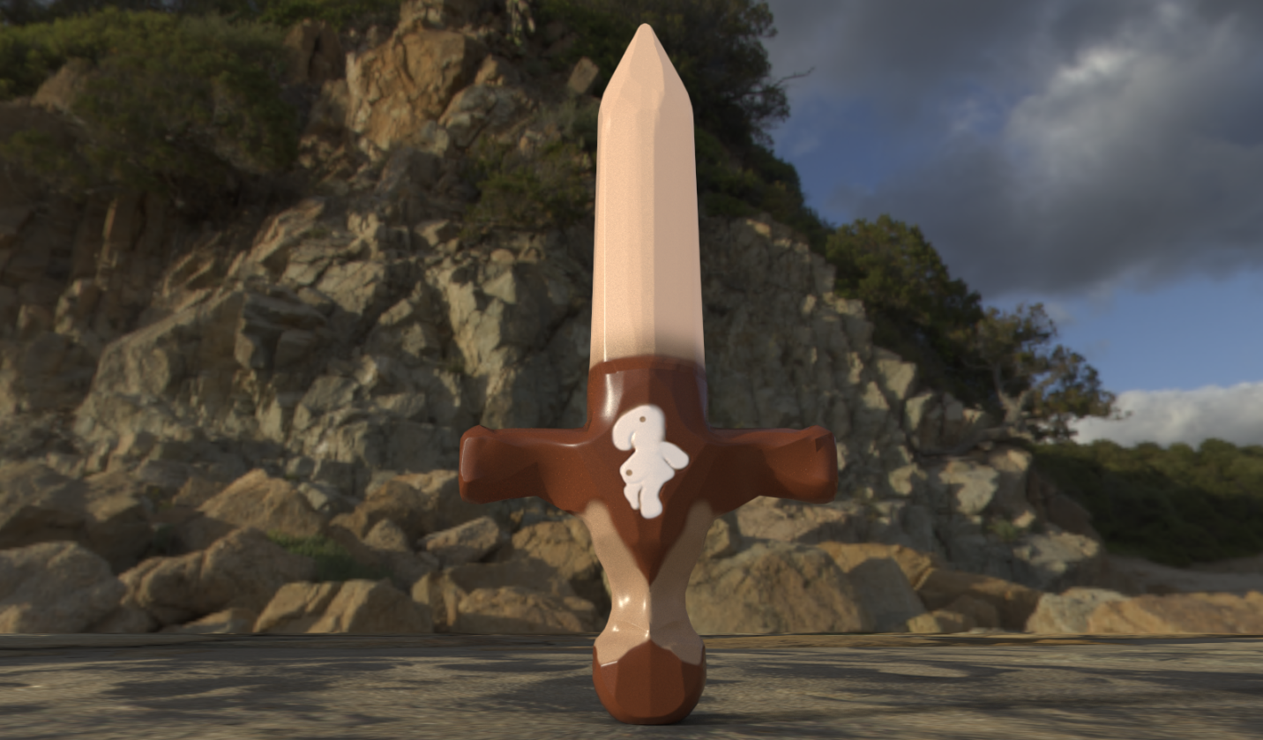

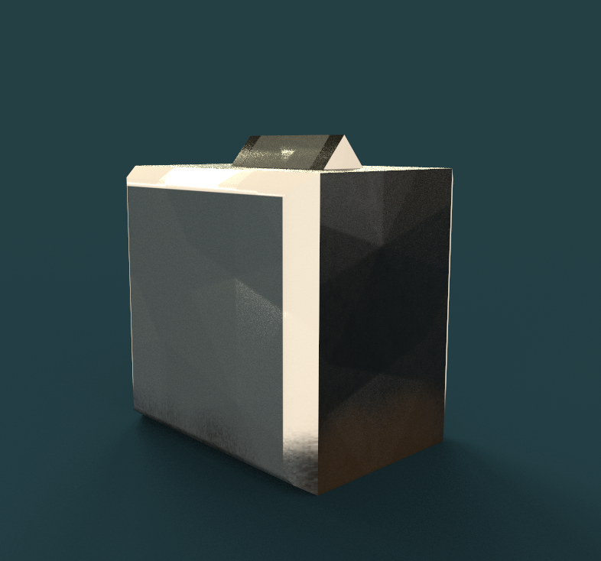

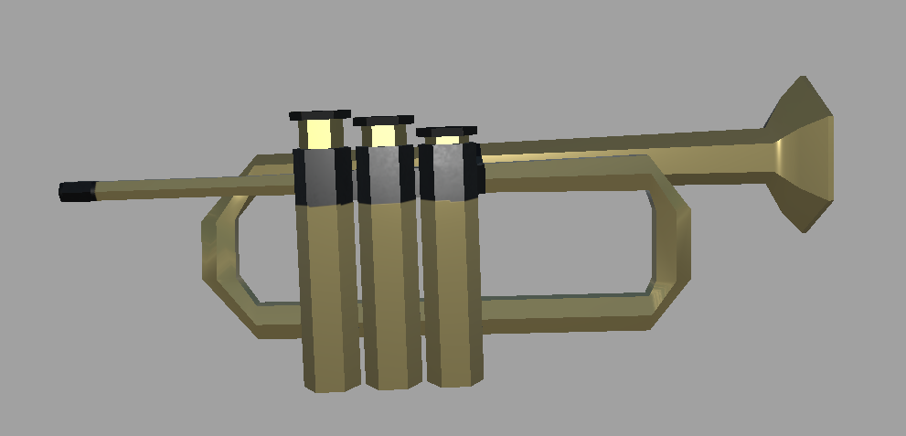

**Mushroom Plant Resource**

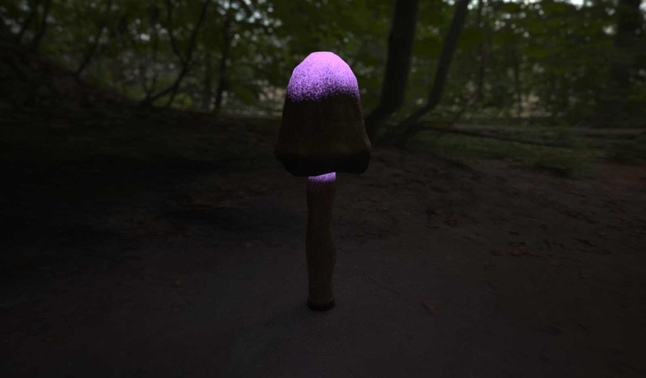

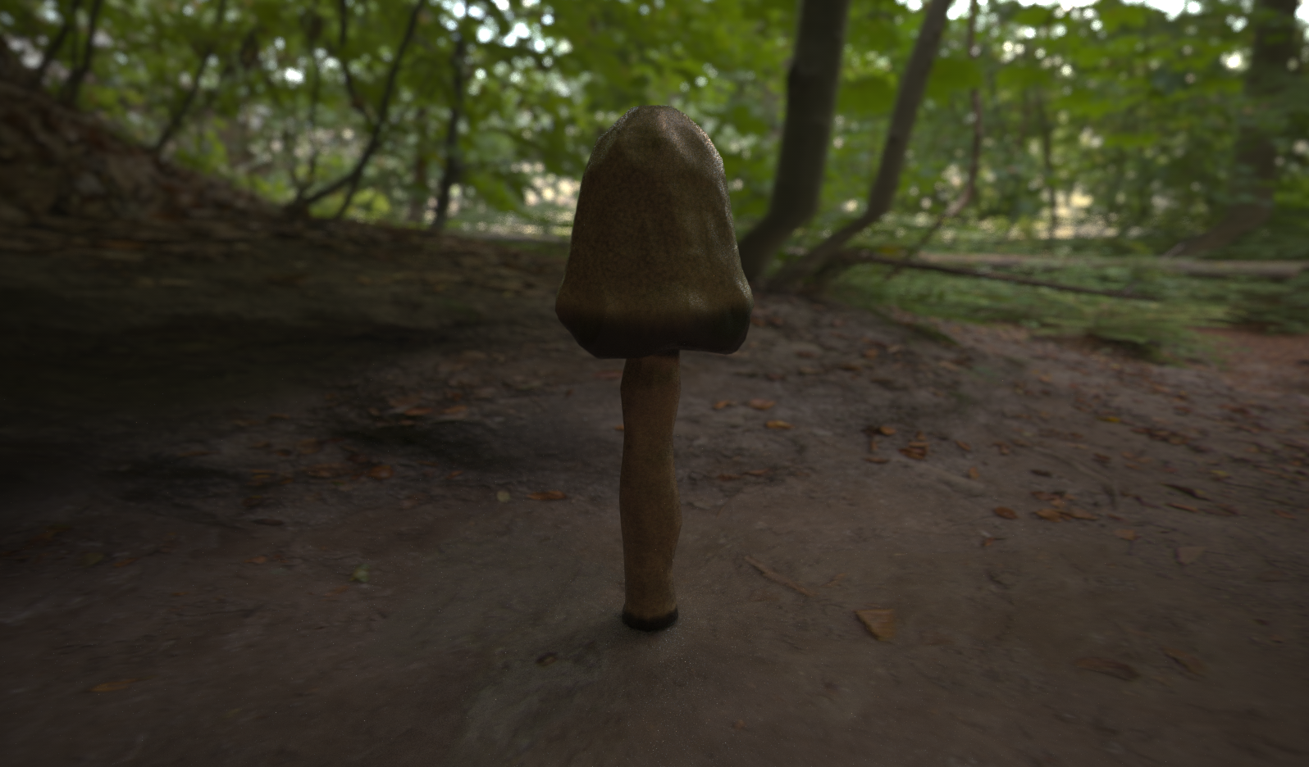

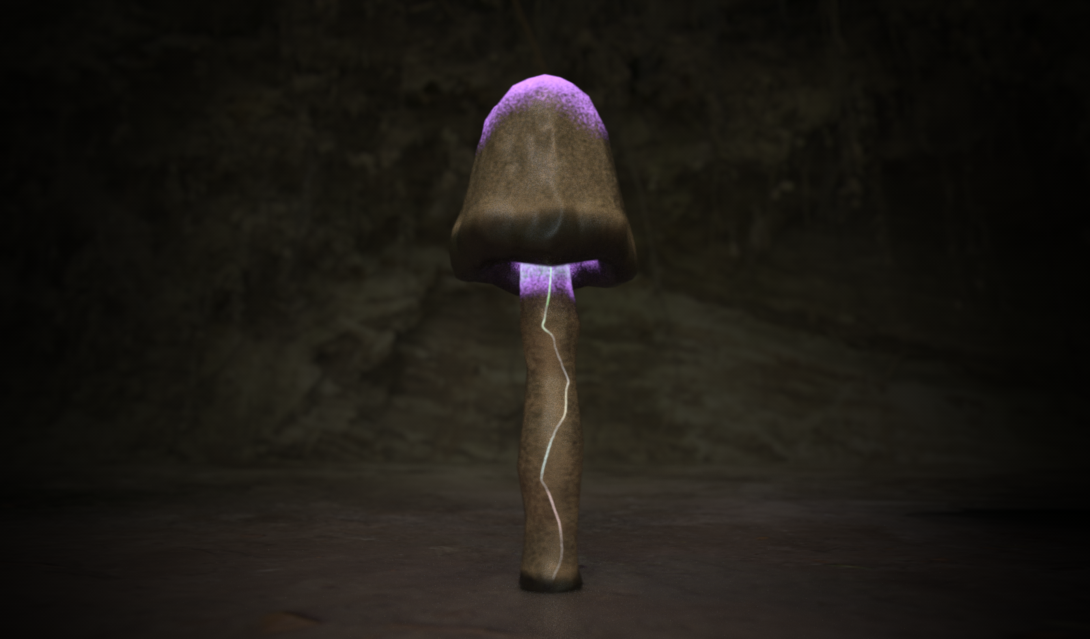

**Convoy (Legacy Asset)**

